SOFTWARE ENGINEERING & WEB DEVELOPMENT LAB MANUAL
PROJECT CASE STUDY: LEDGERLY — INVOICE & QUOTATION GENERATOR PWA

Experiment No. 8: Interaction Design and Detailed UML Artifacts

1. Pre-Requisites
• Proficiency in Human-Computer Interaction (HCI) concepts: Personas, Scenarios, Task Flows, and Wireframing.
• Familiarity with Nielsen's 10 Usability Heuristics and Shneiderman's 8 Golden Rules.
• Knowledge of UML behavioral (Sequence, Activity) and structural (Class, Component) diagrams.

2. Objective
To develop an interaction design model and prepare UML design artifacts for Ledgerly, including user personas, task flows, wireframes, Class Diagram, Sequence Diagrams, and Component Hierarchy.

3. User Personas
Persona 1: Rohan Patil (Freelance Web Developer, Age 24)
• Goals: Send polished quotations to international & domestic clients; receive payment via UPI.
• Pain Points: Heavy accounting software with monthly subscription charges; spreadsheet calculation errors.
Persona 2: Meera Sharma (Boutique & Retail Agency Owner, Age 38)
• Goals: Create GST-compliant invoices with CGST/SGST breakdowns; track clients with overdue partial payments.
• Pain Points: Losing customer records when switching devices; complex tax filing preparations.

4. UML Sequence Diagrams

4.1 Invoice Builder & Signature Pipeline

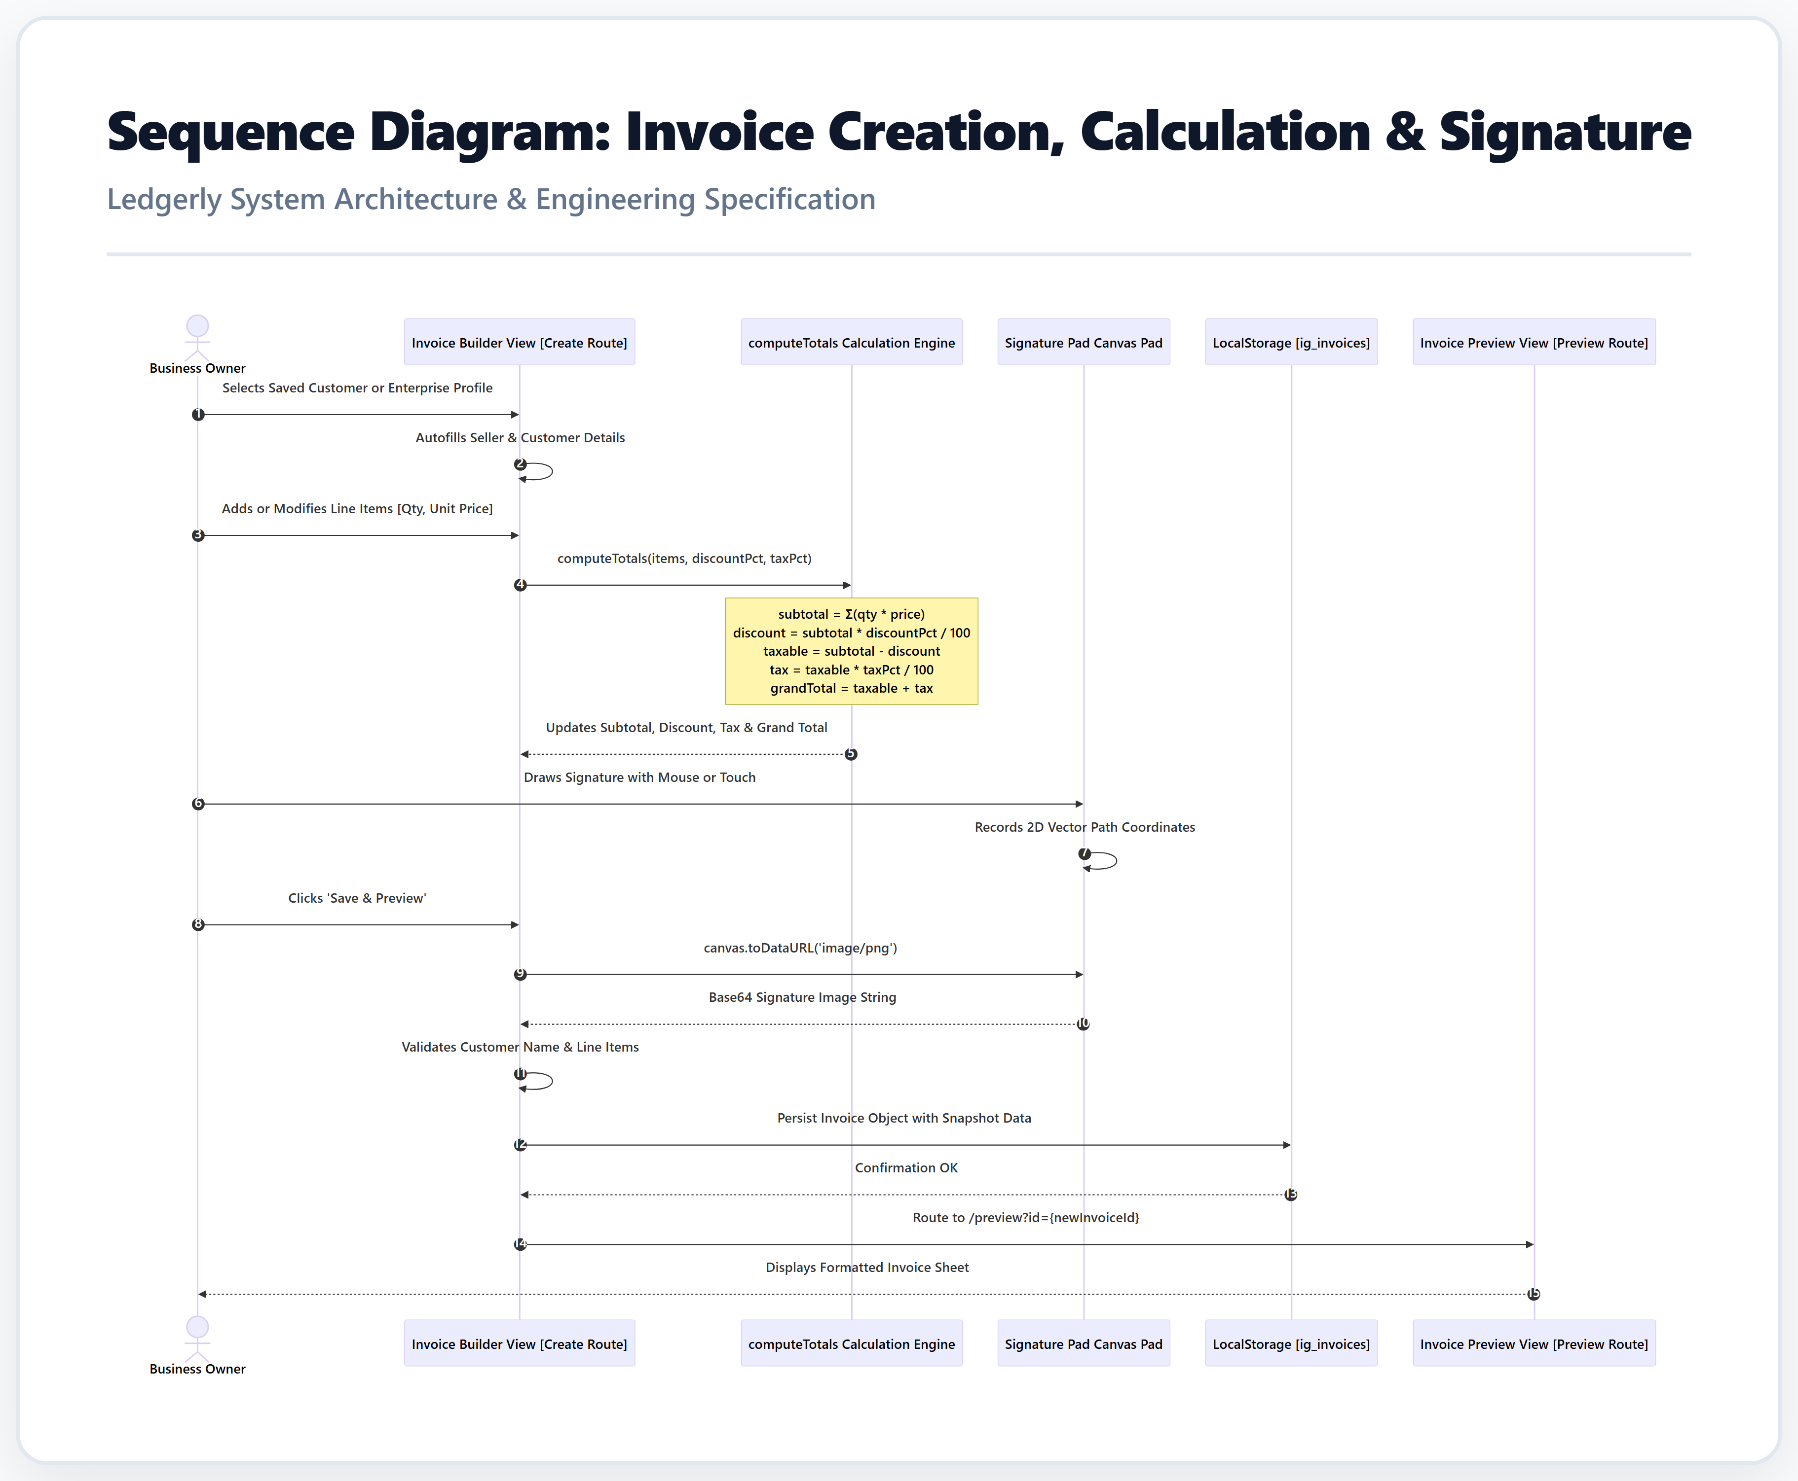
Figure: Sequence Diagram: Invoice Creation and Digital Signature

4.2 Payment Settlement & Receipt Dispatch

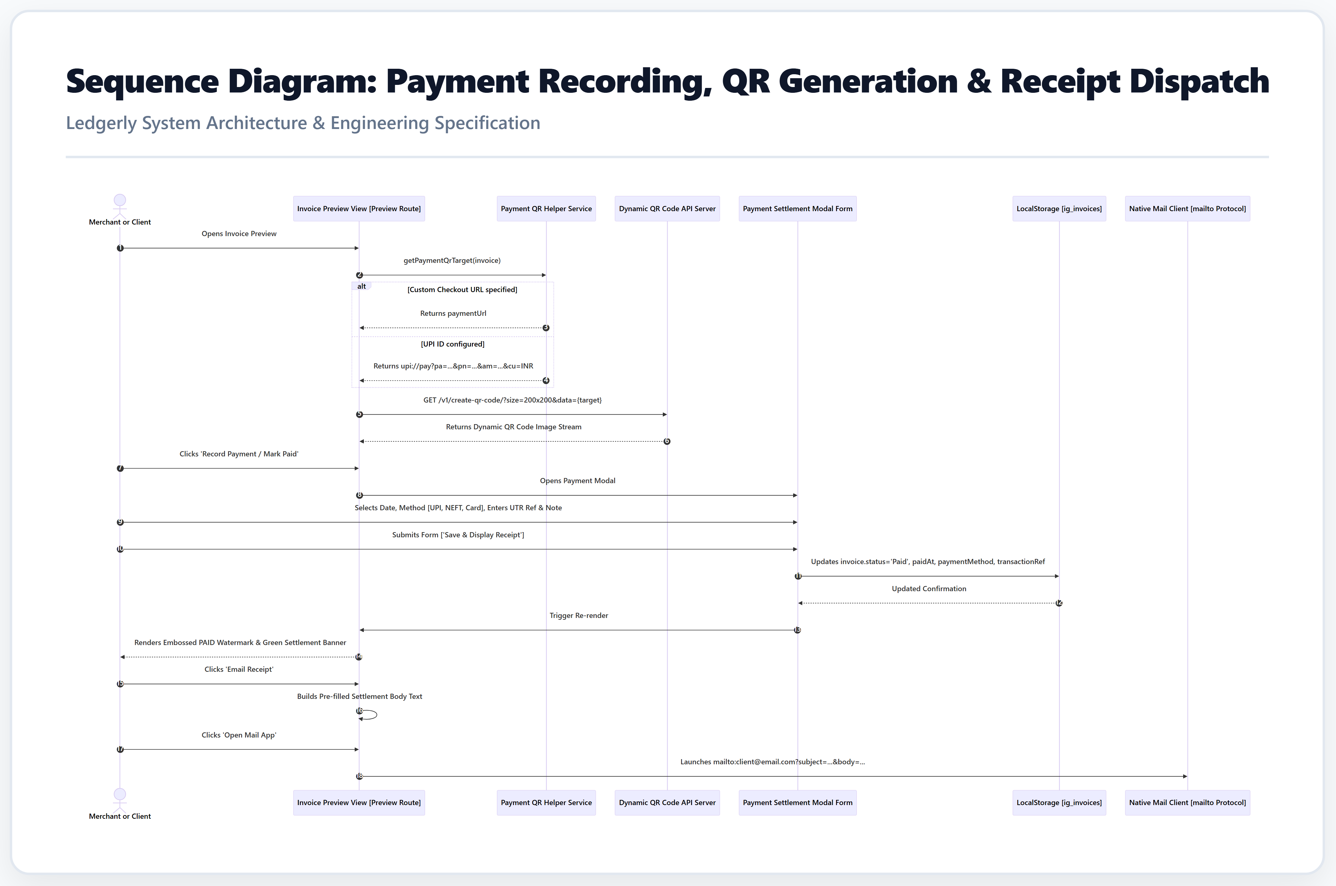
Figure: Sequence Diagram: Payment Recording and Settlement

5. Invoice Lifecycle State Machine

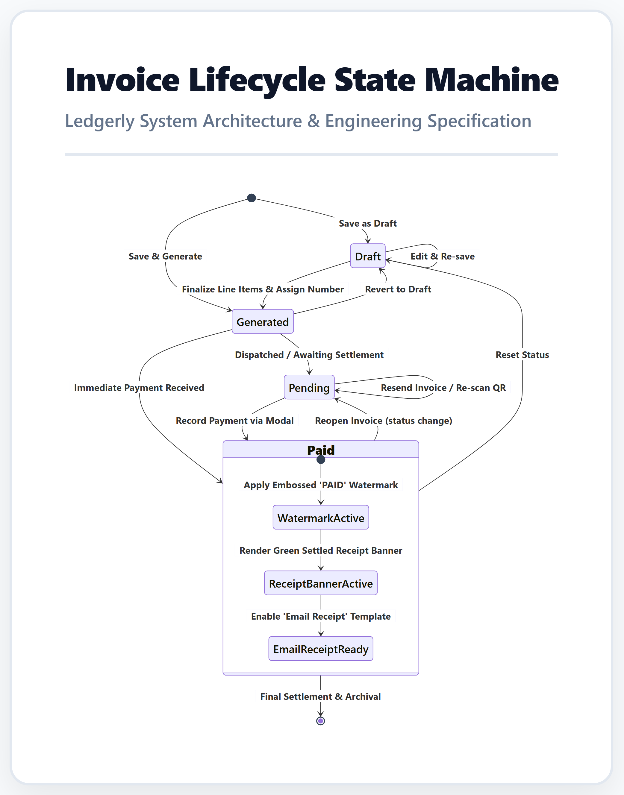
Figure: State Machine: Invoice Lifecycle (Draft -> Generated -> Partially Paid -> Paid)

6. Conclusion
Experiment 8 applied interaction design techniques and UML modeling to establish a clear architectural blueprint for Ledgerly, ensuring high modularity, intuitive UX, and clean separation of concerns.

